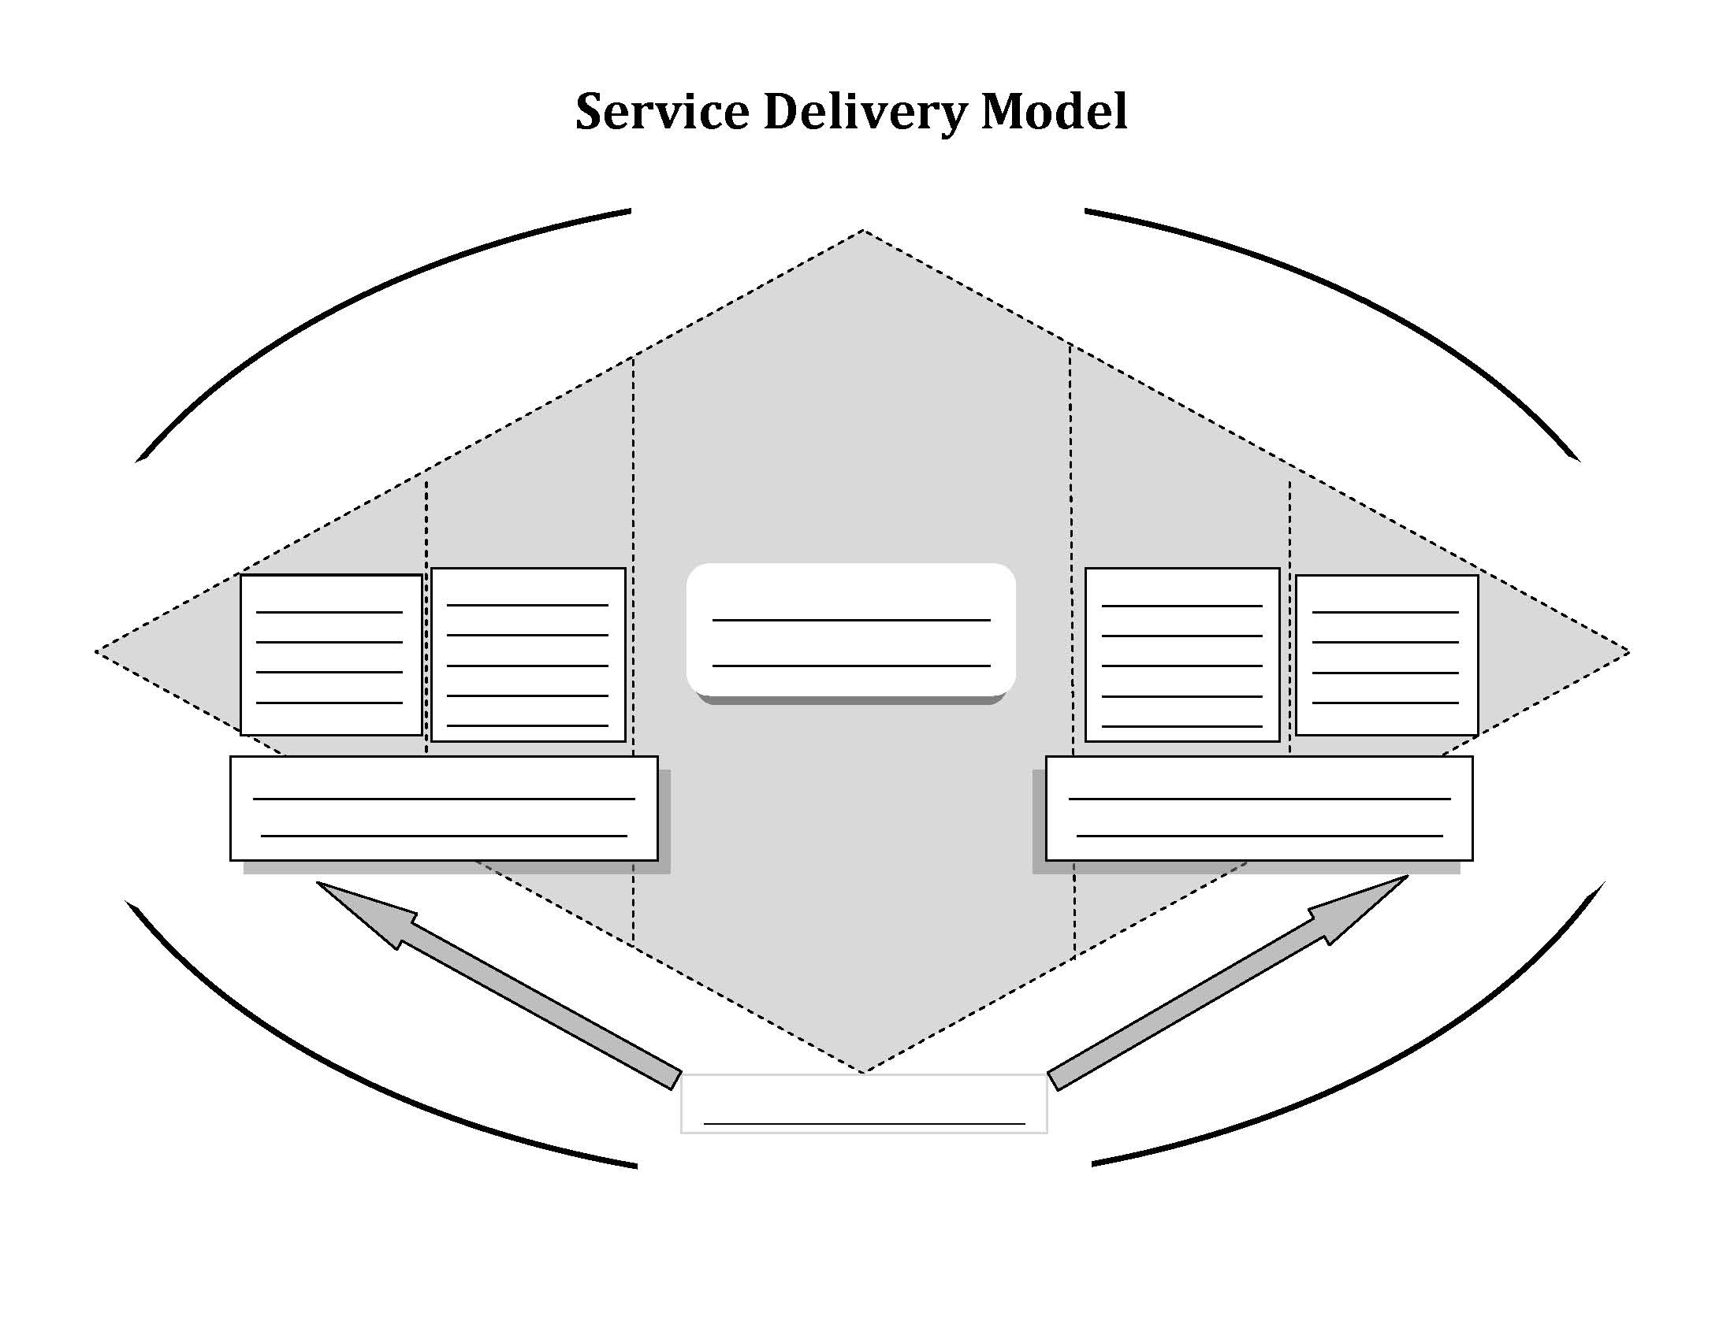
Service Delivery Model Graphic
Activity 6.1

